# Capstone Ideas – Danielle Medeiros

## Find your perfect pet

1. What goal will your website be designed to achieve?
   1. This application will allow users to search the PetFinder Database for available pets based on their selected preferences. Upon signing in / signing up, users are able to create custom search criteria for the types of pets they want to adopt, and will be able to save search results to their saved list.
2. What kind of users will visit your site? In other words, what is the demographic of your users?
   1. Users of this site will be those looking to adopt a new pet, or those interested in seeing what types of pets are available to adopt.
3. What data do you plan on using? You may have not picked your actual API yet, which is fine, just outline what kind of data you would like it to contain.
   1. <https://www.petfinder.com/developers/v2/docs/>
   2. This application will utilize many of the query parameters available on the petfinder api to create custom search preferences for each user.
   3. Results will show a card for each adoptable pet meeting the search criteria, including a picture, name, etc, and a link to the adoption site.

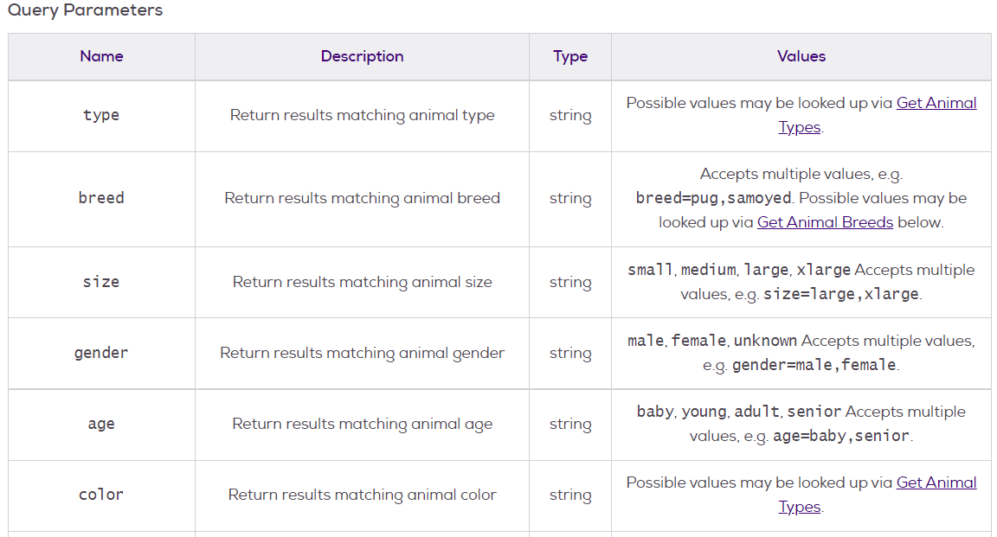



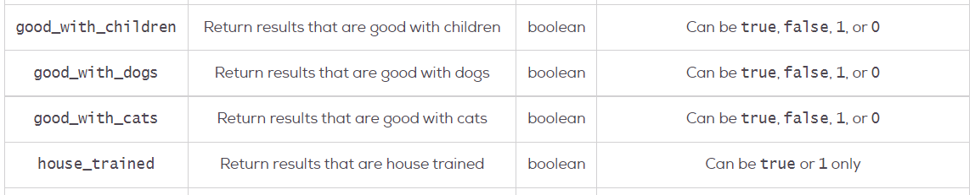



1. In brief, outline your approach to creating your project (knowing that you may not know everything in advance and that these details might change later). Answer questions like the ones below, but feel free to add more information:
   1. What does your database schema look like?
      1. Search fields within the user table will be saved search terms used to generate search results on a user’s homepage

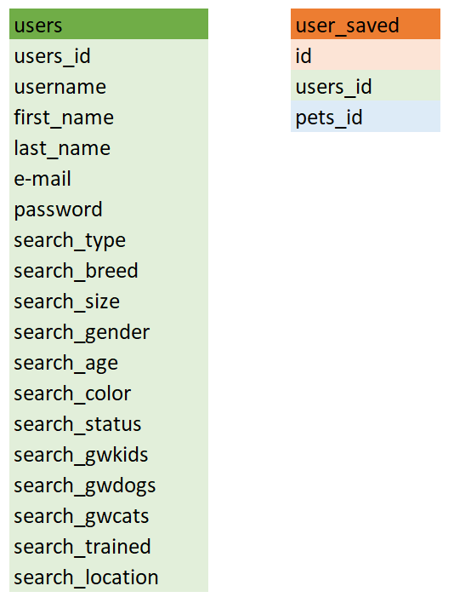

* 1. What kinds of issues might you run into with your API?
     1. I would like to have a user complete their preference list and send the request to the API. I’m wondering if there will be issues to have multiple search queries at the same time.
  2. Is there any sensitive information you need to secure?
     1. User’s passwords will need to be secure
  3. What functionality will your app include?
     1. Log in / Sign up: Users can create and personalize their own account
     2. Account information will include search preferences and saved pets through the user and user_saved tables
     3. User preferences (Search_”” within the user table) will request information and generate results from the petfinder API.
     4. Search results will be shown in two locations: a preview on the user’s homepage and a full list on a separate page
     5. Results will link to a Pet detail page which will show a picture and API information on the pet
     6. Users can add and remove results from their saved list using a visual toggle
     7. A user’s saved list will also be shown in two locations: a preview on their homepage and a full list on a separate page
     8. User’s can edit their account details (including search preferences)
     9. User’s can delete their account
     10. User’s who chose to not create a log in will be directed to a search page where they can input their search criteria to find available pets. Pets will show on the same page as the search, and results will provide links to each Pet’s detail page. All other access to the site will be restricted
  4. What will the user flow look like?

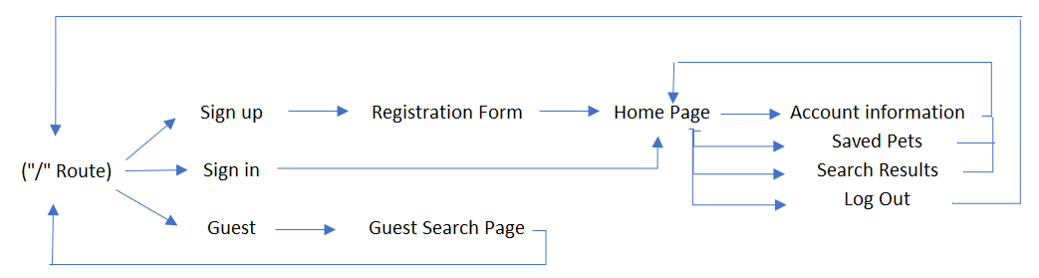

* 1. What features make your site more than CRUD? Do you have any stretch goals?
     1. User’s can create and customize their preferences in a private account
     2. This site will save a user’s preferences to generate API results when reaching a user’s homepage
     3. Users are able to create a saved list based on search results

## Page Layout

